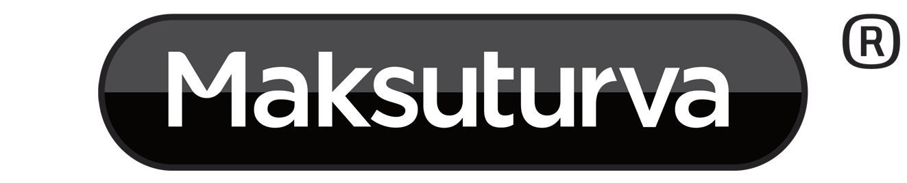
Maksuturva/eMaksut
Payment Gateway Plugin for
WooCommerce 2.2 -

version 1.0

Table of Contents
1 Changes 3
2 Service requirements 3
3 System requirements 3
4 Limitations and notes 3
5 Package contents 4
6 Installation 4
6.1 Upgrading an existing plugin 4
6.2 Intalling the plugin 4
7 Configuration 5
7.1 Enable / Disable 5
7.2 Title and Customer Message 5
7.3 Sandbox mode 5
7.4 Seller id 5
7.5 Secret Key and Secret key version 5
7.6 Gateway URL 6
7.7 Maksuturva Payment Prefix 7
7.8 Emaksut 7
8 Language customization 7
9 Testing the installation 7
9.1 Testing in Maksuturva test environment 7
10 Paying through Maksuturva Payment Gateway 8
11 Administration 8
11.1 Payment verification 9

Changes
date | version | description
06.03.2015 | 1.0 | Initial release.

Service requirements
The plugin requires an activated Maksuturva payment service to work. You can order a Maksuturva account at https://www.maksuturva.fi/tilaapalvelu. For testing purposes you can order a test credentials to Maksuturva's test environment at http://test1.maksuturva.fi/tilaapalvelu.
Without an active Maksuturva (test environment or production environment) account you can test the plugin using the Sandbox test mode. See more about testinG in section 9.

System requirements
The Maksuturva Payment Gateway plugin for WooCommerce was tested on and requires the following set of applications in order to fully work:
Requirement | Supported versions
WooCommerce | - 2.2.10, 2.3.x
Wordpress | - 4.0
PHP | - 4.x  - 5.x
PHP cURL Module | - Any
PHP mbstring module | - Any

There is no guarantee that the plugin is fully functional in any other environment which hasn't such requirements.

Limitations and notes
This version of the Maksuturva Payment Gateway plugin is known to have the following limitations:
- The plugin ignores additional fees (e.g. invoicing fee) added to orders in Maksuturva service. The payments are accepted but the extra fee is not seen in WooCommerce by customer or admin in the user interface. The order amount or order row information is not updated in cases where extra fees have been added. Instead, the total amount can be seen in Maksuturva KauppiasExtranet.

Package contents
This guide assumes that all the package files were correctly downloaded by the user. The uncompressed folder structure is presented in Illustration 1.
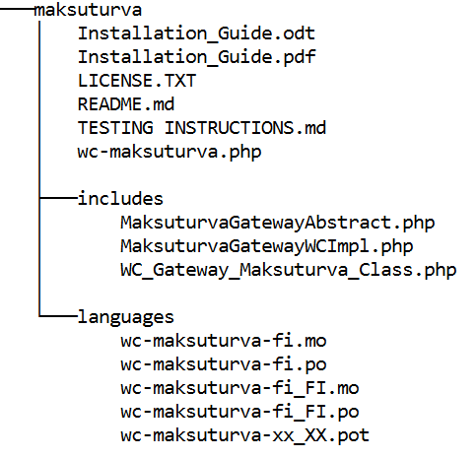Illustration 1: Module package folder structure

Installation
Prior to any change in your environment, it is strongly recommended that you backup the entire existing WordPress and WooCommerce installation.

Upgrading an existing plugin
Upgrade the plugin by first deactivating and uninstalling the previous version of the plugin. Then continue by installing the new version by the following installation instuctions.
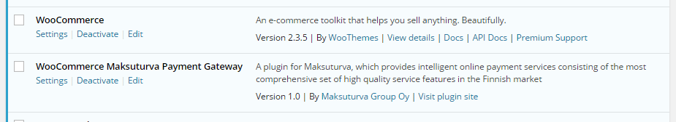Illustration 2: Maksuturva WooCommerce Payment Gateway plugin installed in WordPress plugins page

Intalling the plugin
Save the plugin folder as a zip-archive. In WordPress plugins page select Add New and then Upload Plugin. Choose the plugin zip-archive file from your computer and select Install Now. After installation activate the plugin.

Configuration
Before you're able to use Maksuturva Payment Gateway plugin in your WooCommerce store, you need to do some configurations in the plugin's settings page (see Illustration 3). You can access the settings through the plugin in WordPress plugins list (as seen in Illustration 2) or by selecting Maksuturva in WooCommerce settings page's Checkout tab. Remember to Save changes afterwards.

Enable / Disable
Checking this checkbox activates Maksuturva as a payment option for your customers in checkout process.

Title and Customer Message
You can set the payment option name and a description for your customers. The individual payment methods that are available for your customers depend on your Maksuturva service package and the order amount.

Sandbox mode
When the Sandbox mode is activated the plugin uses Maksuturva's general test credentials which directs all payment attempts to Maksuturva's Sandbox test page. On the test page one can validate the order data e.g. money amounts, product descriptions etc. In the Sandbox test page one can also test how the orders will look to the customer or in the admin page when one has returned from Maksuturva with a succesfull payment, error or by cancelling the payment.
As the WooCommerce won't know the difference between payments made in sandbox mode or in Maksuturva's test or production environment, remember to deactivate sandbox-mode after you've oped the store for live customers. If you are uncertain whether an order has an actual payment or has it been made in a test environment you can check all the payments in Maksuturva's Kauppias Extranet -services.

Seller id
With a Maksuturva service you'll get a unique seller id. This id is ignored when using the Sandbox mode.

Secret Key and Secret key version
Maksuturva services use your seller id and secret key combination to authenticate your webstore. Secret key is used to sign all payments coming from your store to Maksuturva so it is important to keep the secret key secret. Never send the secret key (or a screenshot picture of it) in an unencrypted email or place it somewhere where an outsider could have an access to it.
Illustration 3: Maksuturva Payment Gateway settings
Your intial secret key's version number is 001. If your secret key has been compromized you can order a new secret key from Maksuturva. In that case you need to update the version number to refer to the new secret key you have taken in to use. Your Seller id and Secret Key are ignored when using the Sandbox mode.

Gateway URL
Maksuturva production environment (where the customers can make an actual payments) uses an SSL-secured connection in an URL https://www.maksuturva.fi.
If you are testing the service using Maksuturva's test environment (where you can walk through the whole payment process without using actual money), the unsecure connection uses URL http://test1.maksuturva.fi. Remember to change the URL to refer back to production mode before you open your store to actual customers.
Both service environments are separate and have their own service accounts so you have to order the credentials separately.

Maksuturva Payment Prefix
Maksuturva service requires a unique ids for each payments. Orders with payment id that has already been used are not accepted.
As the payment id is calculated from the order numbers, if you move your Maksuturva account to a new ecommerce software installation and order numbering starts from beginning a confict in payment id numbers can occur. Adding a unique prefix for payment ids after re-installation of the web store you can prevent the collision of the payment id numbers. By default the prefix is empty

Emaksut
Maksuturva offers services with Maksuturva Satisfaction guarantee service as well as direct payment services know as eMaksut. Check this chekbox if you are using an eMaksut service, keep it unchecked if not.

Language customization
Payment Gateway Module can translated to different languages and individual texts can be altered by editing .po -files in the languages directory and compiling them as corresponding .mo -files. One common tool for this in Windows- and Mac-environments is Poedit (poedit.net). Remember to add the new and altered files to the plugin zip-archive and reinstall the plugin to WordPress (See section 6.1).

Testing the installation
It is strongly encouraged that the Maksuturva Payment Gateway plugin is thoroughly tested before taking it into use in on production web store. It is essential to verify that customer and product information, prices, taxes and discount as well as payment message verifying hash are transmitted correctly to Maksuturva.

Testing in Maksuturva test environment
When Sandbox mode is disabled, module acts as in production mode and order confimation directs buyer to Maksuturva payment page. If actual Maksuturva credentials are used real money transactions will occur.
If Gateway URL is set to refer to Maksuturva test environment (http://test1.maksuturva.fi) it is possible to try the full online bank payment and invoice payment process without using actual money. Test environment uses different credentials than Maksuturva production environment and test environment service needs to be ordered separately from the actual Maksuturva service. More information about testing is available at http://docs.maksuturva.fi/.

Paying through Maksuturva Payment Gateway
Perform a purchase of items and at the checkout select Maksuturva as the payment option during the checkout (see Illustration 4). You'll be redirected to Maksuturva service where you can proceed with the payment method of your choise. After completing the payment you'll see confirmation (see Illustration 5). The store admin will see the order status to change from Pending to Processing.
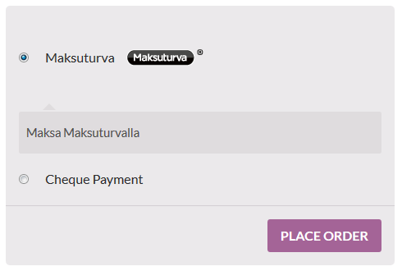Illustration 4: Selecting Maksuturva as a payment method
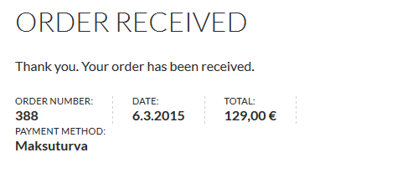Illustration 5: Message the customer receives in WooCommerce after completing the payment

Administration
When a customer chooses to place order and is transferred to Maksuturva service the order's status is “pending”. When the payment is placed and customer returns to shop page from Maksuturva the status is changed to “processing”. If an error occurs or customer cancels the payment, customer is returned to the store and the order status is changed to error or cancelled.

Payment verification
The Maksuturva Payment Gateway Plugin automatically verifies all payments from Maksuturva excluding the payments that have already received a response of a successful payment. Pending payments that have not received a verification in two hours are regarded as cancelled.
You can also validate erroneous, cancelled and pending payments manually by clicking Check pending payments at the top of Maksuturva settings page (see Illustration 3).
Payments are not verfied while in Sandbox-mode and verifications do not work for bank payments when using Maksuturva test environment.

